**Gas Laws**

1. Rearrange the Ideal Gas Law Equation for each case to show that it is consistent with the given law or hypothesis.

a) Boyle’s Law

b) Charles’ Law

2. When 9.55 g of solid sodium hydroxide is dissolved in 100 mL of water at 23.6 °C, the temperature of the water rises by 23.2 °C. a) What is the final temperature in degrees Celsius?

b) What is the final temperature in Kelvin?

c) What is the temperature change in Kelvin?

3. A helium-filled balloon has a volume of 1.00 L at 101 kPa (1 atm) and a temperature of 23.0 °C. The temperature of the room overnight drops to 15.0 °C, what is the new volume of the balloon at this temperature?

4. A BBQ cylinder contains 9.00 kg of butane, what volume would this occupy when it is released into the atmosphere on a sunny day in Brisbane (30 °C)?

5. When baking a cake at 180 °C, the reaction between sodium bicarbonate and tartaric acid generates 100 mL of CO2 gas – how many molecules of CO2 does this represent? (Assume atmospheric pressure).

6. On a cold, wintry morning, the tires on a car appear flat. How has the air volume changed overnight? Explain what has happened at a molecular level.

7. The figure below represents an ideal gas in a container with a movable friction-free piston.

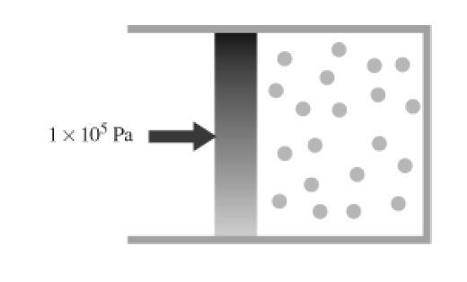

a) The external pressure on the piston exerted by the atmosphere is 1 × 105 Pa. If the piston is not moving, what is the pressure inside the container? Explain in terms of molecular collisions.

b) Redraw the sketch to show what would happen if the temperature of the gas in the container is doubled. Explain in terms of molecular collisions.

8. A sample of air was compressed to a volume of 20.0 L. The temperature was 298 K and the pressure was 5.00 × 105 Pa. How many moles of gas were in the sample? If the sample was collected from air at a pressure of 1.00 × 105 Pa and a temperature of 298 K, what was the original volume of the gas?

9. Body temperature is about 308 K. On a cold day, what volume of air at 273 K must a person with a lung capacity of 2.00 L breathe in to fill the lungs?

10. In a mixture of gases the partial pressure of CH4 (g) is 0.175 atm and that of O2 (g) is 0.250 atm. What is the mole fraction of CH4?